MSapp: version 0.0.1.0

Point to be reviewed :

- All screens
  - batch operation on multiple records High
    - e.g.: Checklist Food Density: “Possibility to attribute the same
coefficients to several selected foods” – Rawcook coefficients of
“potato n.s.” attributed to “potato, new” and “potato old” foods
  - Cascade Delete High
    - ok pour les constituents des foods
    - non pour facets & descriptors

- HHM
  - 2 codes, library & pays High
  - crude photo and "fractionned" photo High

- Quantification by Group-Sub/Group-Sub/SubGroup Medium
  - Attribution of default values per group/sg/ssg for rawcook & edib fields

- Food screens (see below Density, fadebygroup…) High
  - Multi-selection of ((sub-)sub-)groups possible
  - selection of classification optional with display, and filter by food name only in food screens

- Probings High
  - Identify probings as fat or sauce or sweetener or cream (?!) or ...
    - "Necessity to categorized the probings according to the FSS_categories"
    - With impact on FSS (controls)

- Facets / Maxima High
  - Selection of facets to be displayed in screen Maximum.
To attribute food maximum values, not all facet/descriptors are relevant.

- Coefficient & Percentage screens (rawcook & pctfat)
  - Use of Categories → SFG 9.1.1.3.2 High

- EpicText
  - Integration of pictures in EpicText screen for context Medium

- Photo screens (Series, Shapes, HHM, Thickness)
  - Management of high resolution quantification Photos Medium
  - export booklets of quantification Photos Medium
  - Multiple tags (attribution of categories per photo) Medium

Facets/decriptors for foods :

Approach with tree OK/KO?
Closed tree
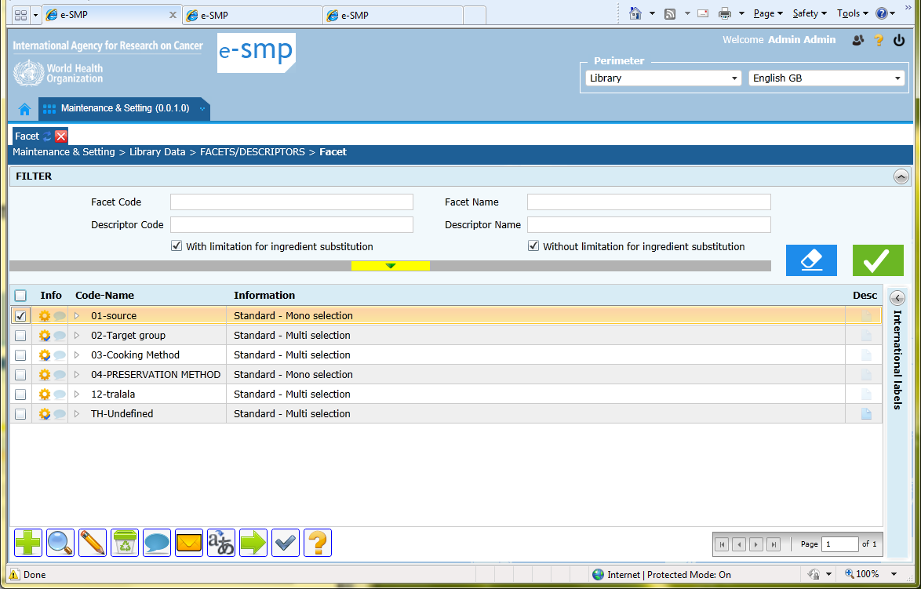

Open tree
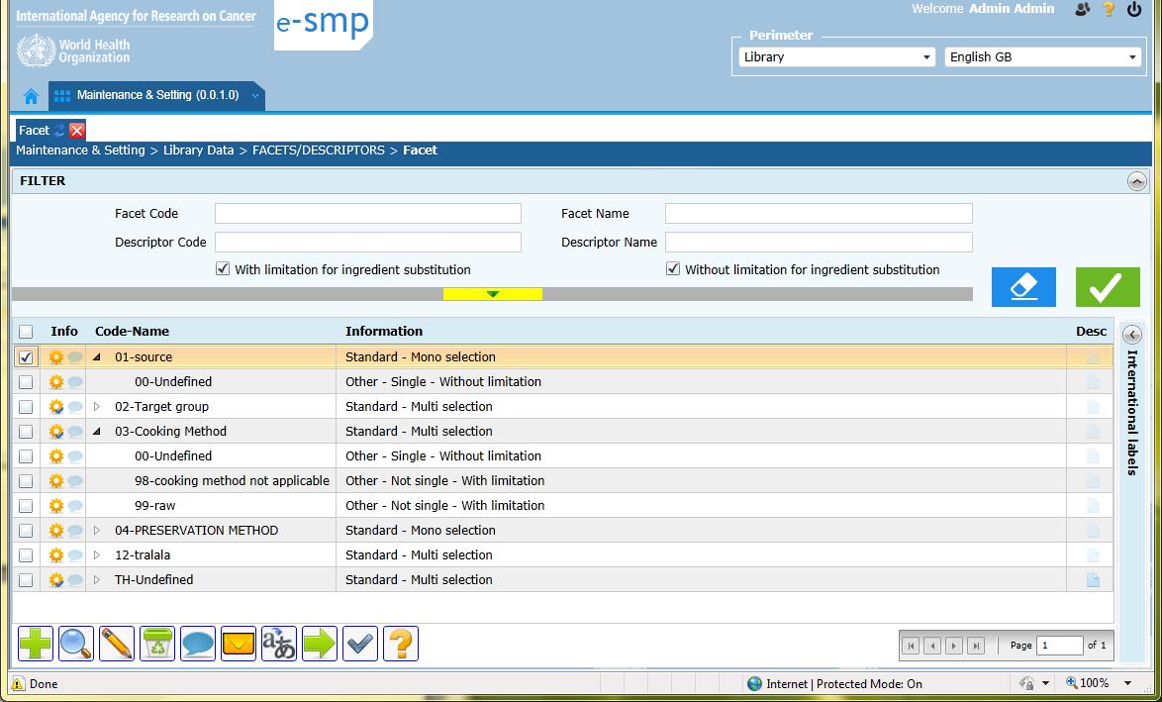
FADEBYGROUP: LIST

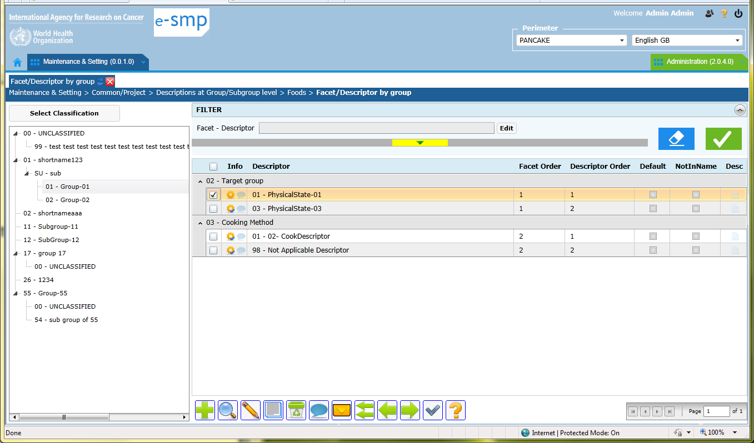

          - Classification on left:
- It is not possible to select more than 1 group/subgroup
- A group or subgroup or sub-subgroup needs to be selected (never all or none)
          - Search “facet – descriptor”:
- it is done within the selected group/subgroup on left never on all the groups/subgroups
          - Proposition:
- A column group/subgroup needs to be added in the list
- Possibility to select none or all or some groups/subgroups
→ This proposition can be apply to all food screens (from food list to food controls)

FADEBYGROUP: FICHE

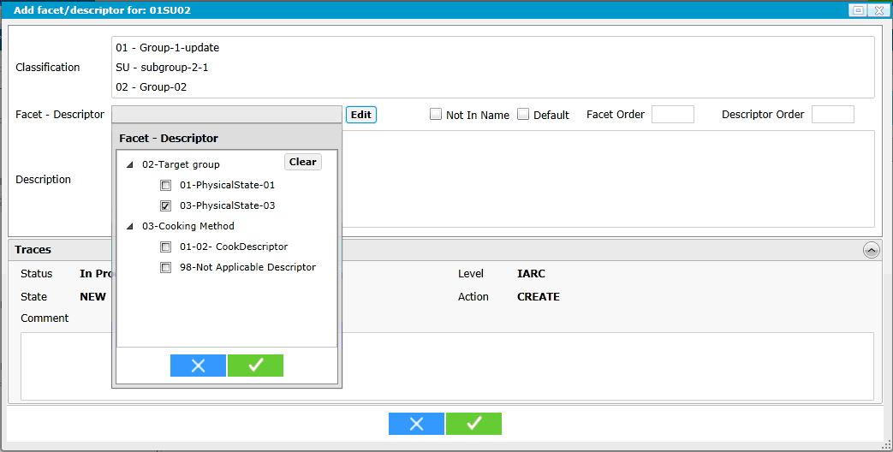

          - Add (green cross):
- It is frustrating to add only one descriptor with the Edit button. We open the facets/descriptors pop-up with all and we can only select one! Regarding the number of descriptors selected per group/subgroup in this table (e.g. can be more than 100 descriptors for 1 subgroup), it will take to much time for the user, to select the needed descriptors following this approach.
- Proposition:
          - Add the possibility to select several descriptors in the same time
          - Give the same status to all these selected descriptors
→ This proposition can be apply to several food screens (from food description to food controls)

FOOD DENSITY: LIST

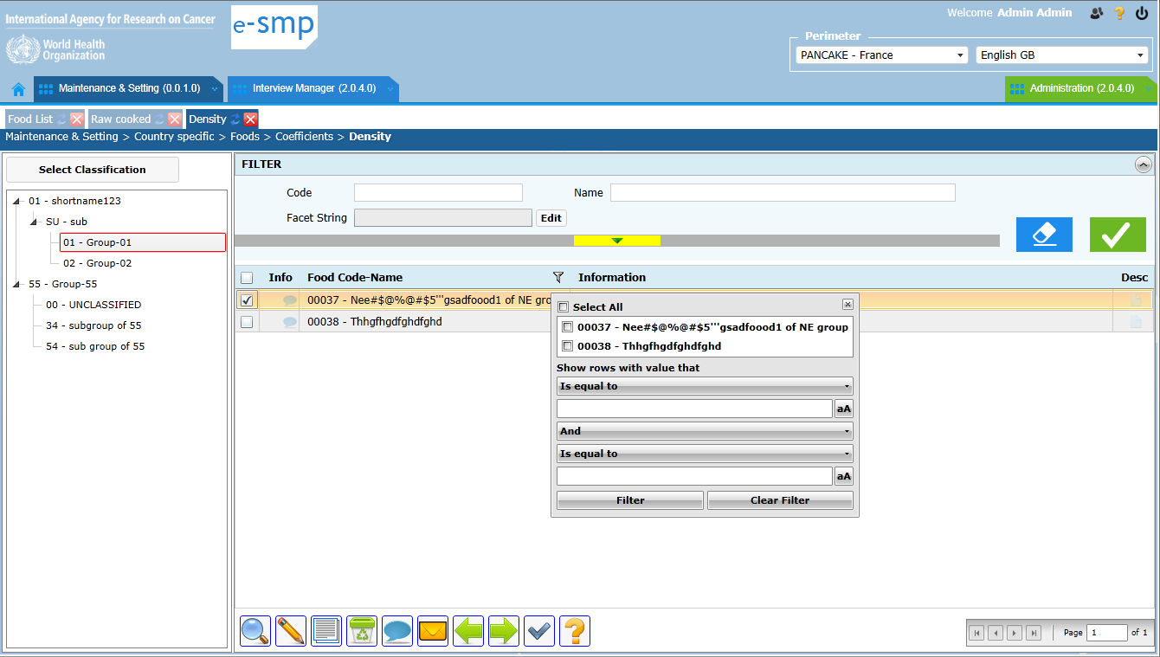

          - Search:
- We have a search part at the top that allow to select one or several foods within the selected sub-group depending of 1 code or same text in the name
- The Filter in the list allows to select several foods within the selected sub-group that don’t have any link (e.g. no same code, no same text in name)
- Facet string: all facets/descriptors defined for a subgroup will be displayed (or all?)
- Proposition:
          - We need to select foods whatever the classification (e.g. “%soya%”)
          - Do we really need the filter (Y/N)?
          - We can need to search facet/descriptor using joker characters (%0204%, %flesh%)
→ This proposition can be apply to several food screens the ones where facet_string is needed

          - batch operation on multiple records
- “Possibility to attribute the same coefficients to several selected foods”
FOOD DENSITY: FICHE
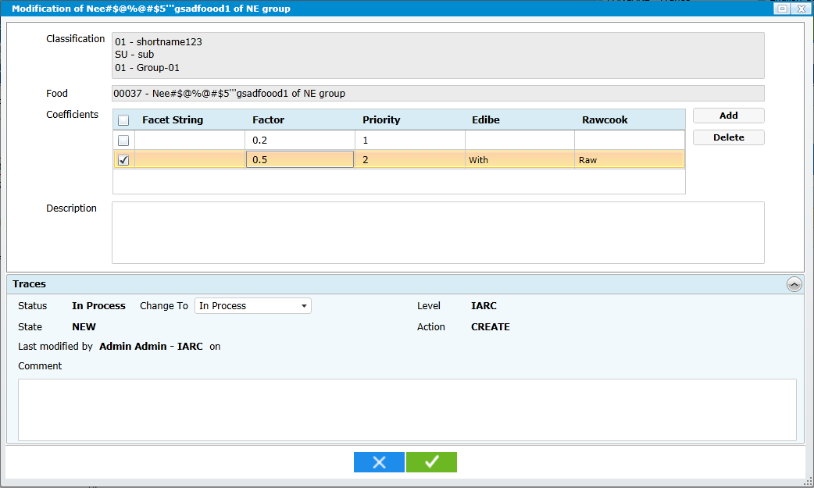
ADD 1 coefficient
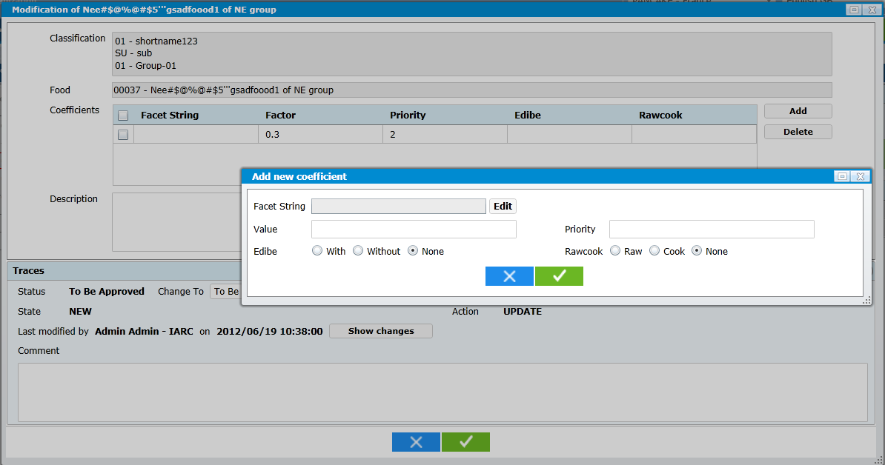
          - Coefficients:
- For 1 food, we can add several coefficients according to different facet string (rawcook & edible)
- The “description” is attached to 1 food (not to the coefficient)
- The trace is attached to 1 food not to 1 coefficient.
- If a coefficient is changed (e.g. status “validated” move to “to be approved”), the user needs click on show changes to see the previous values and what has been changed
- Proposition:
  - The add button will allow modify values directly in the list (not to open another pop-up)
  - In the list add description + the trace variables in order to have them attached to each coefficient not to 1 food
Example of proposition of “% of fats/sauces/sweeteners” screen

